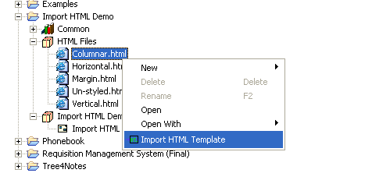
Firstly, I need to implement a specific function of the HTML code, and then import this code into the visual platform, as shown in Figure 18. Columnar.html, Horizontal.html and Margin.html are all a specific HTML code. All what to do is to select Import HTML Template, which will be able to generate an HTML component, as shown in Figure 19. Columnar is a newly generated component and can be dragged after the component to the visual platform within the application. The specific structure of the components shown in Figure 20. The code generated results shown in Figure 21.
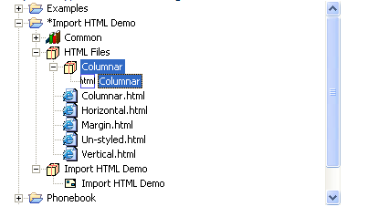
Figure 18 Import HTML view
Figure 19 Generates a component view
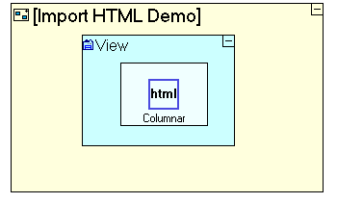
Figure 20 Component application screenshots
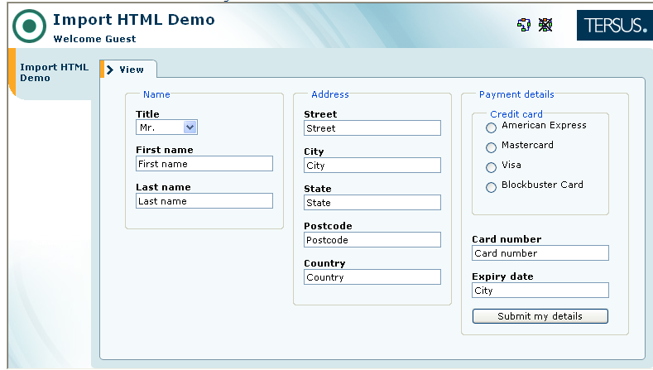
Figure 21 Generate page screenshots
The above is the introduction of specific HTML code into the visualization platform for application, but if there is a change, how to make changes. The following discussion is about when and where need to change the HTML code. For example, we need to add two text boxes in the above components: First and Last text box, and a Submit button. First of all, I need to add the three parts of the HTML into the background code, and then in Figure 22, right-click the components to select Synchronize with HTML Template, which the HTML code can change to the component. Figure 23 is the view of the HTML widget after the change.
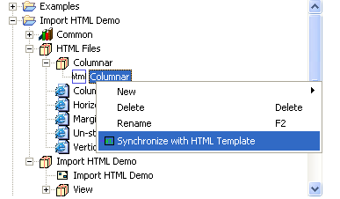
Figure 22 Synchronization code change view
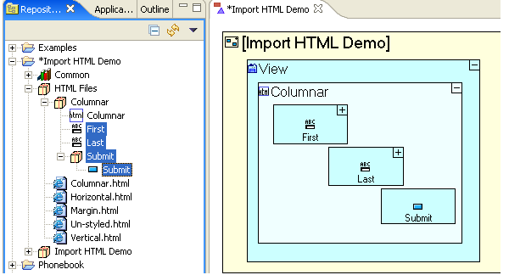
Figure 23 changed component view
According to the above description that can be achieved by HTML and visual platform's integration, and thus be able to achieve our own design to meet our own requirements of the report, which the report can be real-time update operation.

